Spss Help System

"**SPSS** is a comprehensive **system** for analyzing data. **SPSS** can take data from almost any type of file and use them to generate tabulated reports, charts, and plots of distributions and trends, descriptive statistics, and complex statistical analysis."**SPSS** is the acronym of Statistical Package for the Social Science.

SPSS Custom Dialogs – Quick Introduction

SPSS custom dialogs are extensions of SPSS’ point-click menu, officially known as the GUI (“graphical user interface”).

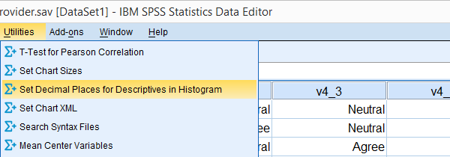*SPSS Custom Dialogs in Menu*

Custom dialogs are kept in files with the .spd file extension. After installing a custom dialog file, it will appear in the menu just like an SPSS' built-in command. The difference, however, is that SPSS users can build and share custom dialogs themselves, which isn't as difficult as it may seem.  
SPSS Tutorials offers freely downloadable custom dialogs under Tools. Custom dialogs were introduced to SPSS in version 17.

Installing SPSS Custom Dialogs

**Option 1:** the easiest way to install a custom dialog is simply double clicking the .spd file. A dialog window will pop up and ask you whether you'd like to install or edit the custom dialog.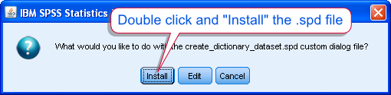*SPSS Custom Dialog Installation*

**Option 2:** If you have more than one SPSS version installed on your computer, right-click the .spd file and select the version in which you'd like to install it. Again, the installation window will pop up after doing so.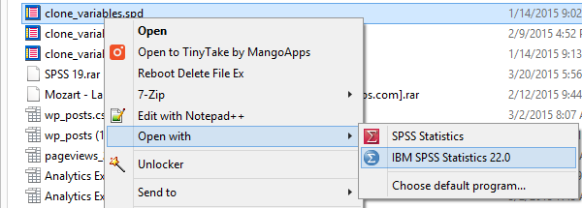*SPSS Custom Dialogs in Menu*

**Option 3:** alternatively, select Utilities SPSS Menu Arrow Custom Dialogs SPSS Menu Arrow Install Custom Dialog.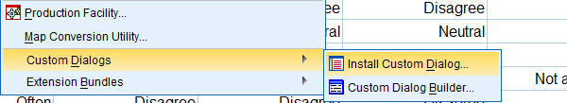*SPSS Custom Dialogs in Menu*Navigate to the .spd file. Clicking Open will launch the installer window.

In some cases, SPSS may throw an SPSS Error Saving Dialog Specification when you first install a custom dialog. Don't let this put you off. Troubleshooting this common error is not hard and needs to be done only once; subsequent custom dialogs will install more smoothly.

Uninstalling SPSS Custom Dialogs

Unfortunately, uninstalling SPSS custom dialogs is not straightforward and we strongly dislike the way this has been implemented in SPSS.

**Option 1:** open an .spd file as if you'd like to install it. This doesn't have to be the custom dialog you'd like to uninstall; *any* .spd file will do. Now, select Edit as if you'd like to modify the custom dialog.

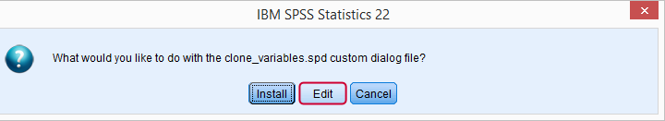

This will open an SPSS custom dialog builder window. You're probably not familiar with this window but don't panic, everything will be OK. Navigate to File SPSS Menu Arrow Uninstall as shown below.

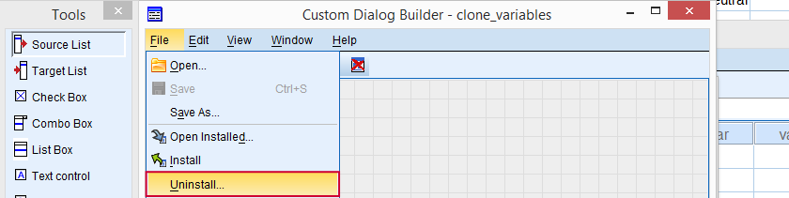*SPSS Custom Dialog Builder Window*

You now get a list of all custom dialogs installed (which is unrelated to the particular .spd file you used in order to arrive here). Select any custom dialog you'd like to uninstall. Clicking Ok will uninstall it after asking whether you'd like to save the contents to a new .spd file. Close the custom dialog builder window without saving it when you're done.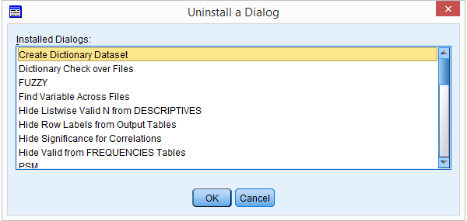

**Option 2:** (re)install *any* custom dialog. After doing so succesfully, a window pops up that tells you where it was installed. Navigate to this folder and delete it entirely. Note: by default, some of these folders may be hidden in MS Windows.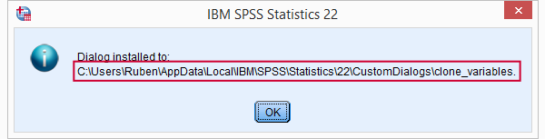

SPSS Custom Dialogs - What are They?

Technically, a custom dialogs (.spd) files are **archive** files: zipped folders holding several smaller files. If you're curious, unzip one with with 7 Zip to see what's inside.  
A custom dialog's main element is the **dialog window** as the end user will see it. It may contain various elements such as plain text, variable selectors, text input and tick boxes.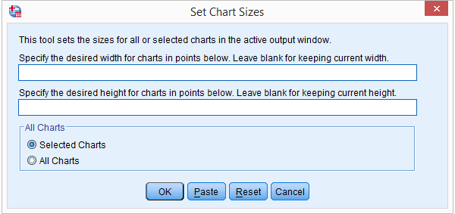*SPSS Custom Dialog Window*